EMPLOYMENT APPLICATION REVIEW SYSTEM (EARS)
Project Plan Document
Version 1.0 approved
Prepared by
Chisom Ugochukwu
Yinka Akingbaso
Algoma University
July 29, 2026

1. Introduction

1.1 Purpose
This document presents the project plan for the Employment Application Review System (EARS), a web-based platform designed to streamline the hiring process. EARS supports job posting, application submission, candidate evaluation, and interview scheduling within a single, coherent workflow.

1.2 Scope
EARS serves three user roles — Applicant, Reviewer, and Administrator — and covers the complete hiring workflow from the creation of a job posting through to final candidate selection.

1.3 Objectives
- Reduce manual processing time for job applications by 60%.
- Provide secure, role-based access to sensitive candidate data.
- Enable standardized candidate evaluation using a four-criteria rubric.
- Automate interview scheduling and the associated notifications.

2. Project Organisation

2.1 Team Structure
Team Member | Student ID | Responsibilities
Chisom Ugochukwu | 5148780 | Frontend development, UI/UX design, QA management, documentation
Yinka Akingbaso | 5142977 | Backend development, database design, authentication, API development

2.2 Communication Plan
Channel | Purpose
Daily stand-up (15 min, Discord) | Progress sync and blocker removal
Weekly review (Fridays) | Milestone and progress assessment
Google Drive | Document sharing and version history
GitHub | Code collaboration and pull-request reviews
Jira | Backlog management, sprint planning, and burndown tracking

3. Project Schedule
The project is executed as a one-week sprint, from July 29 to August 4, 2026. Figure 1 shows the planned allocation of deliverables across the sprint, including ownership by team member.
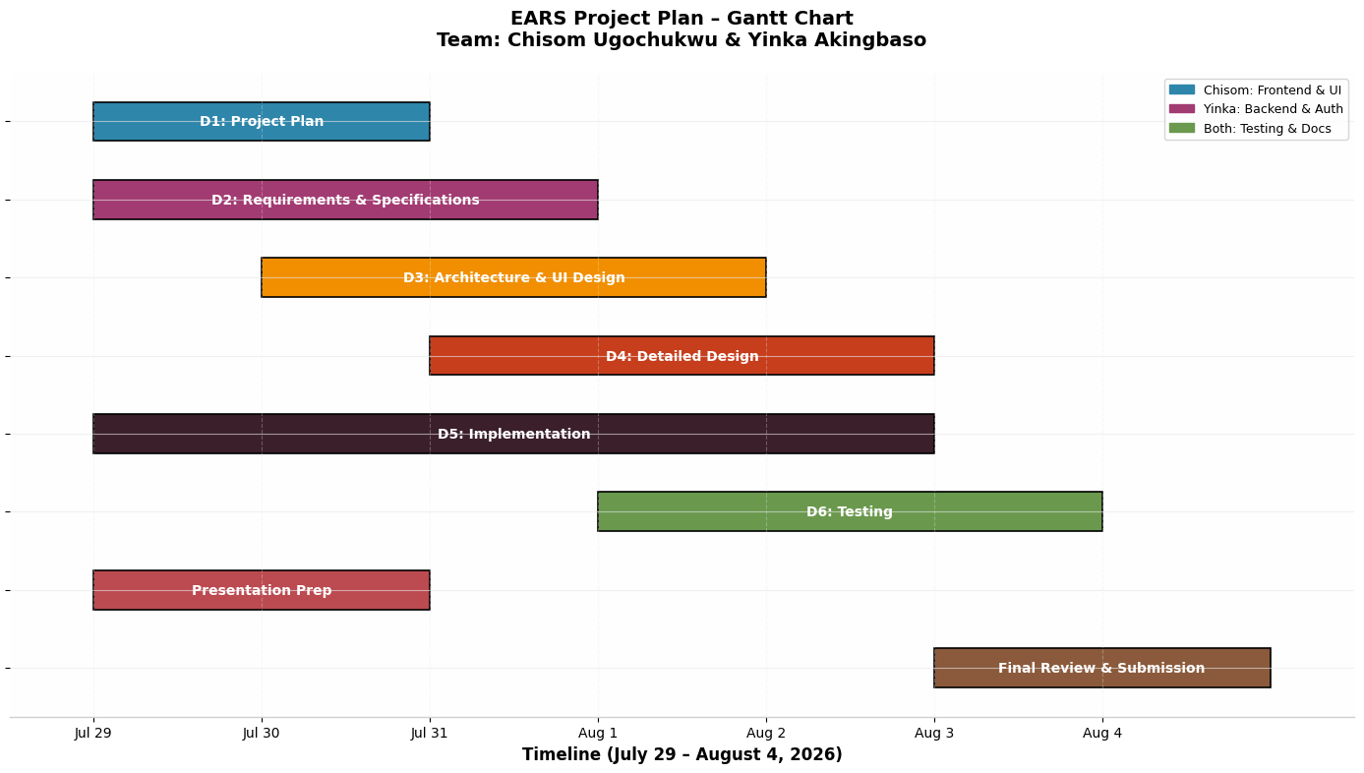
Figure 1: EARS project plan — Gantt chart (July 29 – August 4, 2026)
Five milestones anchor the schedule:
Milestone | Date | Deliverable
M1 | Jul 29 | Requirements finalized and architecture approved
M2 | Jul 30 | Presentation and mid-evaluation completed
M3 | Aug 2 | Core implementation complete (authentication, jobs, applications)
M4 | Aug 3 | Testing and bug fixes complete
M5 | Aug 4 | Final submission

4. Resource Plan

4.1 Hardware
- MacBook Pro (Chisom) — development, testing, and presentation.
- Windows laptop (Yinka) — backend development and database testing.

4.2 Software
Tool | Purpose
Visual Studio Code | Integrated development environment
Node.js v18+ | Server-side runtime
SQLite3 | Embedded relational database
Chrome DevTools | Frontend debugging and responsive testing
draw.io | UML diagram production
Jira | Project management and sprint tracking

5. Risk Management
Eight risks were assessed for probability and impact (Figure 2). Each risk carries a named mitigation strategy, reviewed at every weekly progress meeting.
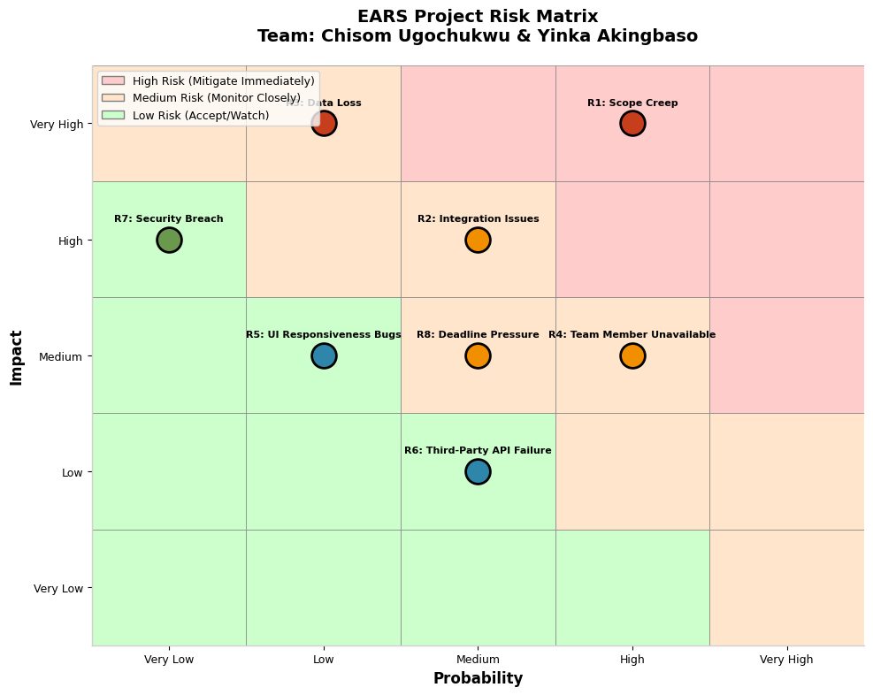
Figure 2: EARS project risk matrix (probability × impact)
ID | Risk | Mitigation Strategy
R1 | Scope creep | Strict change-control process; weekly scope reviews
R2 | Integration issues | Daily integration testing; API documentation maintained
R3 | Data loss | Automated SQLite backups; version control via Git
R4 | Team member unavailable | Cross-training on critical components; shared documentation
R5 | UI responsiveness bugs | Responsive design framework; multi-device testing
R6 | Third-party API failure | Graceful error handling; fallback UI states
R7 | Security breach | bcrypt password hashing; 30-minute session timeout; input validation
R8 | Deadline pressure | Buffer time built into the schedule; priority-based task management

6. Quality Assurance Plan
- Code reviews are mandatory for all pull requests before merging.
- Unit testing covers all backend API endpoints.
- Integration testing verifies frontend–backend communication.
- User acceptance testing is performed with dedicated demo accounts.
- Security testing targets authentication flows and role boundaries.

